Adjusted eye aspect ratio for strong eye blink detection based on facial landmarks

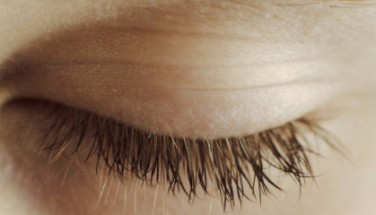

**P6**

**P5**

**P4**

**P3**

**P2**

**P1**

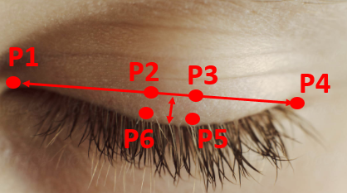

talkingFace Dataset TalkingFace.avi

**Experiment 1**

**Threshold = 0.2**

Video info

FPS: 30.0

FRAME_COUNT: 5000

DURATION (s): 166.67

Statistics on the prediction set are

TOTAL NUMBER OF FRAMES PROCESSED: 5000

NUMBER OF CLOSED FRAMES: 292

NUMBER OF BLINKS: 42

Statistics on the test set are

TOTAL NUMBER OF FRAMES PROCESSED: 5000

NUMBER OF CLOSED FRAMES: 153

NUMBER OF BLINKS: 61

EYE CLOSENESS FRAME BY FRAME TEST SCORES

ACCURACY: 0.9678

AUC: 0.9486

CONFUSION MATRIX:

[[4697 150]

[ 11 142]]

FALSE POSITIVES:

11 out of 153 positive labels (0.0719%)

FALSE NEGATIVES:

150 out of 4847 negative labels (0.0309%)

PRECISION, RECALL, F1 scores:

precision recall f1-score support

0 1.00 0.97 0.98 4847

1 0.49 0.93 0.64 153

accuracy 0.97 5000

macro avg 0.74 0.95 0.81 5000

weighted avg 0.98 0.97 0.97 5000

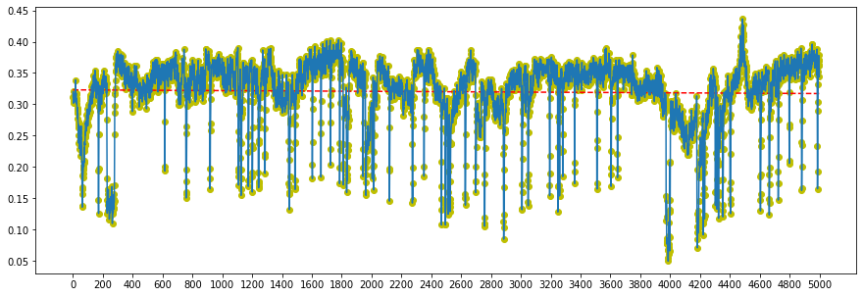

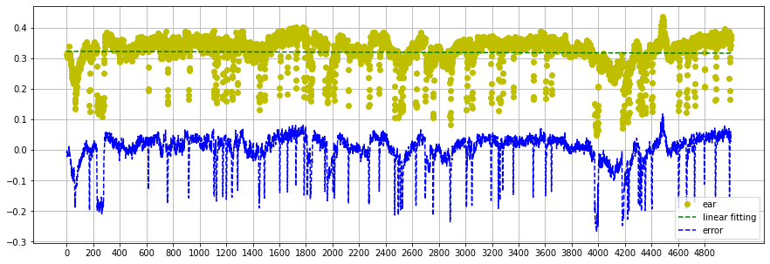

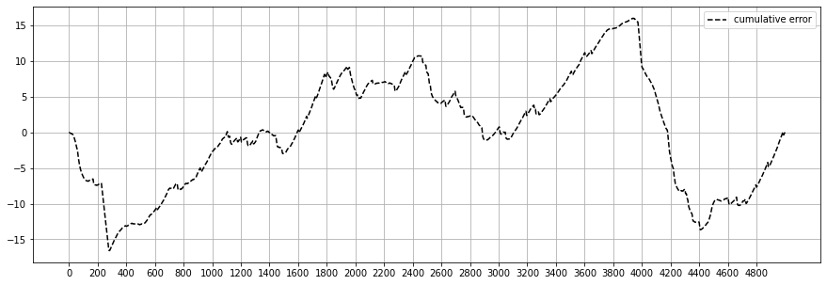

8th blink started at: 1201th frame, middle of action at: 1202th frame, ended at: 1203th frame

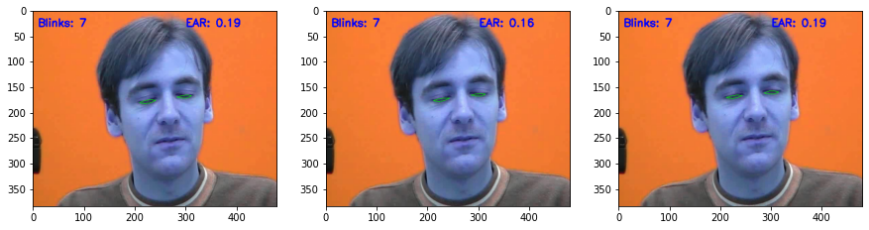

9th blink started at: 1242th frame, middle of action at: 1244th frame, ended at: 1246th frame

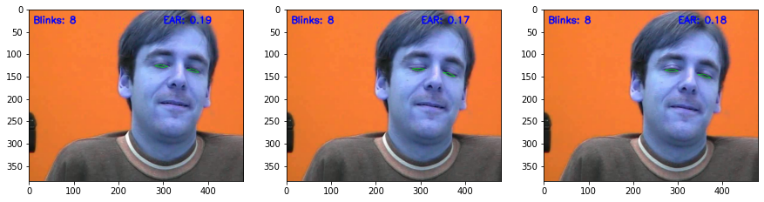

10th blink started at: 1449th frame, middle of action at: 1451th frame, ended at: 1453th frame

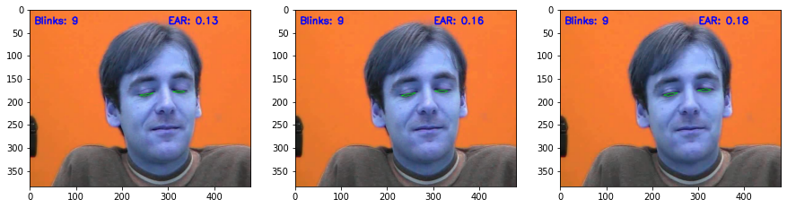

11th blink started at: 1487th frame, middle of action at: 1488th frame, ended at: 1489th frame

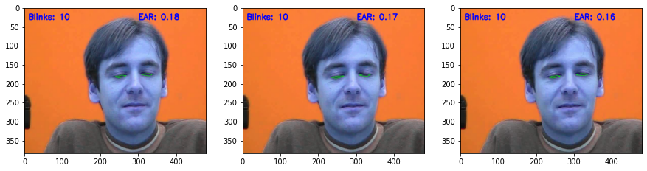

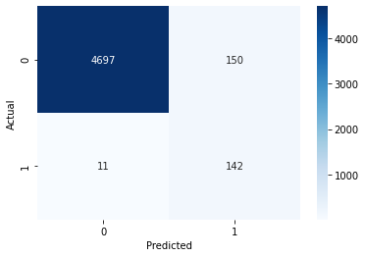

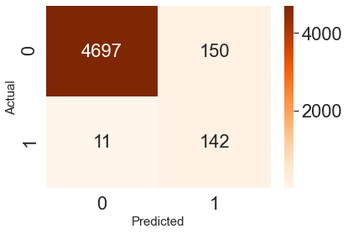

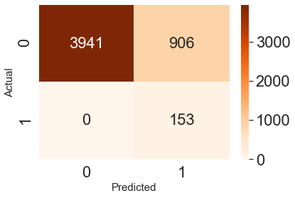

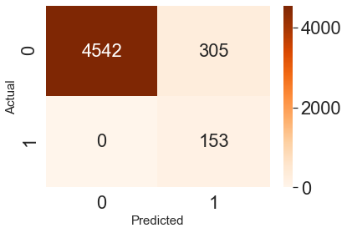

Video info

FPS: 30.0

FRAME_COUNT: 5000

DURATION (s): 166.67

Statistics on the prediction set are

TOTAL NUMBER OF FRAMES PROCESSED: 5000

NUMBER OF CLOSED FRAMES: 323

NUMBER OF BLINKS: 45

Statistics on the test set are

TOTAL NUMBER OF FRAMES PROCESSED: 5000

NUMBER OF CLOSED FRAMES: 153

NUMBER OF BLINKS: 61

EYE CLOSENESS FRAME BY FRAME TEST SCORES

ACCURACY: 0.9640

AUC: 0.9656

CONFUSION MATRIX:

[[4672 175]

[ 5 148]]

FALSE POSITIVES:

5 out of 153 positive labels (0.0327%)

FALSE NEGATIVES:

175 out of 4847 negative labels (0.0361%)

PRECISION, RECALL, F1 scores:

precision recall f1-score support

0 1.00 0.96 0.98 4847

1 0.46 0.97 0.62 153

accuracy 0.96 5000

macro avg 0.73 0.97 0.80 5000

weighted avg 0.98 0.96 0.97 5000

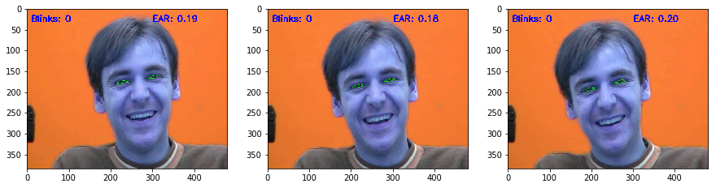

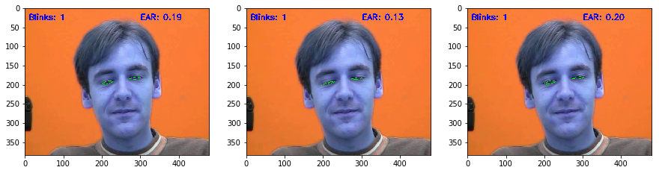

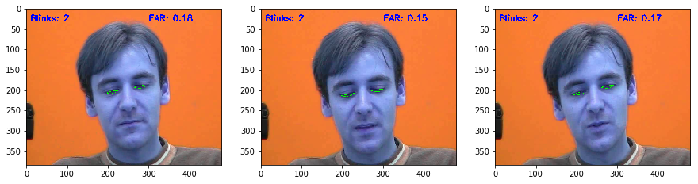

#get first n frames and plot it with linear regression

n = 100

data100 = data[:n]

m,b = np.polyfit(np.arange(n),data100, 1)

print("SCOPE = {:.5f}".format(m))

plt.plot(np.arange(n),data100,'yo', np.arange(n), m*np.arange(n)+b, '--g');

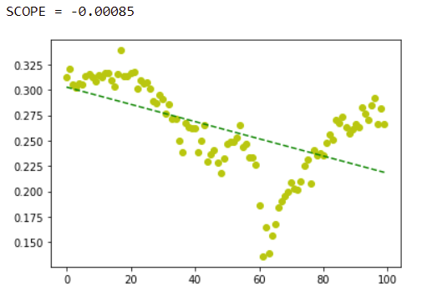

#get first n frames and plot it with linear regression

n = 250

data100 = data[:n]

m,b = np.polyfit(np.arange(n),data100, 1)

print("SCOPE = {:.5f}".format(m))

plt.plot(np.arange(n),data100,'yo', np.arange(n), m*np.arange(n)+b, '--g');

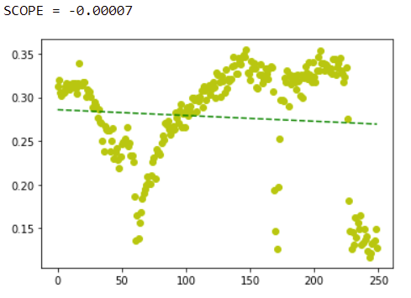

#get first n frames and plot it with linear regression

n = 1000

data100 = data[:n]

m,b = np.polyfit(np.arange(n),data100, 1)

print("SCOPE = {:.5f}".format(m))

plt.plot(np.arange(n),data100,'yo', np.arange(n), m*np.arange(n)+b, '--g');

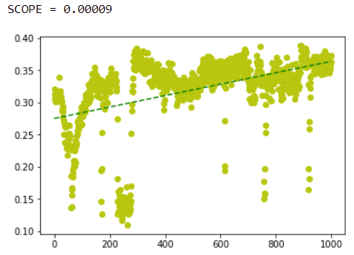

#Plot_avg_ear melalui frame_info_df # plot whole data

data = np.array(frame_info_df['avg_ear'])

plt.figure(figsize=(15,5))

plt.xticks(np.arange(0, len(data)+1, 200))

m,b = np.polyfit(np.arange(len(data)),data, 1)

print("SLOPE = {:.5f}".format(m))

plt.plot(np.arange(len(data)),data,'yo', np.arange(len(data)), m*np.arange(len(data))+b, '--r')

plt.plot(data);

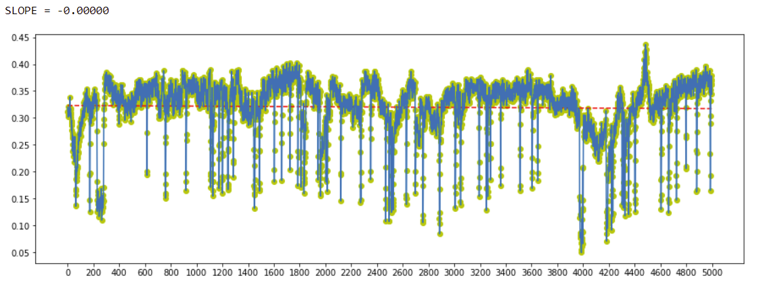

# calculate a limit_n for 10 secs with using fps of the video

n = 222.00000

m = 0.00032

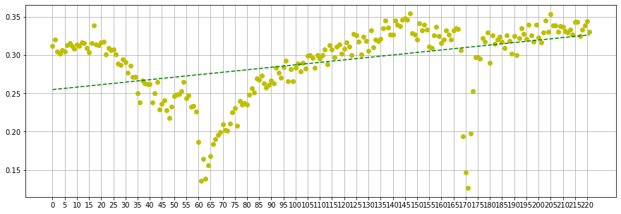

First blink, the blink which we detected between 30th and 90th frames. With enlarged tails it can be anywhere between 0-163.

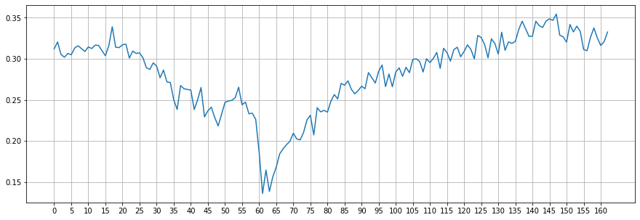

Second blink, the blink between 138-218.

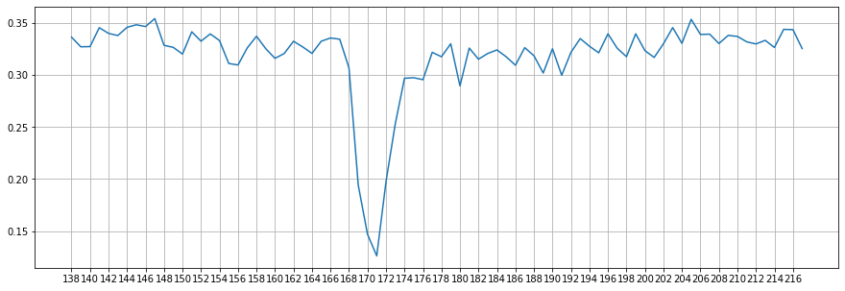

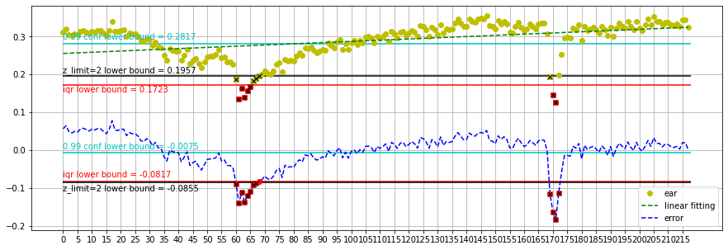

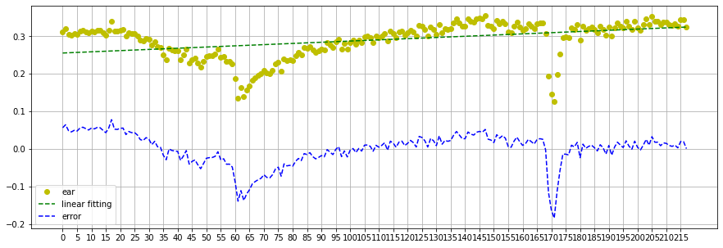

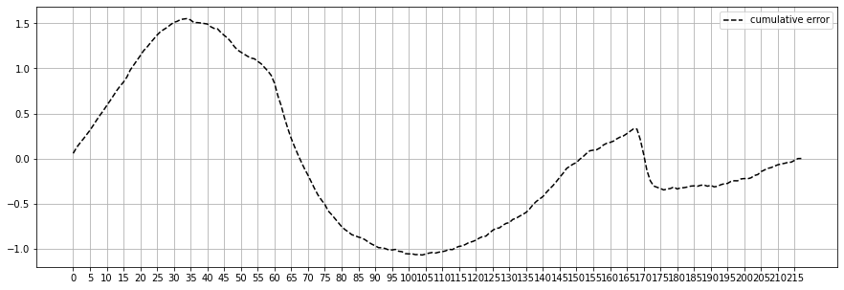

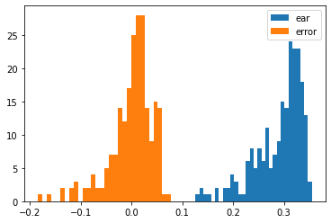

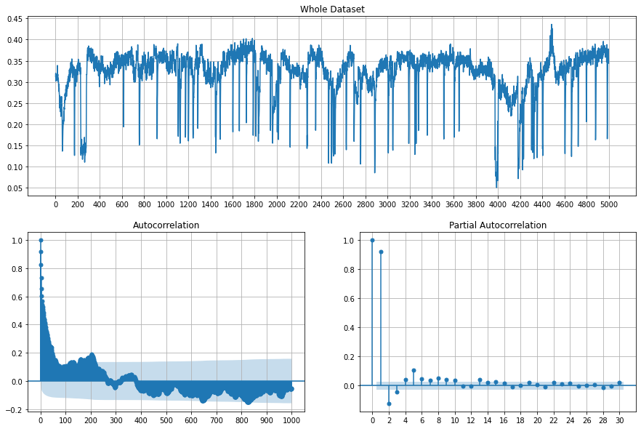

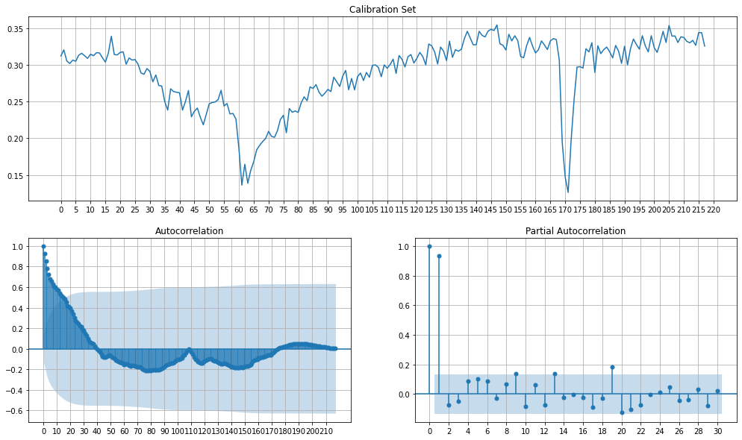

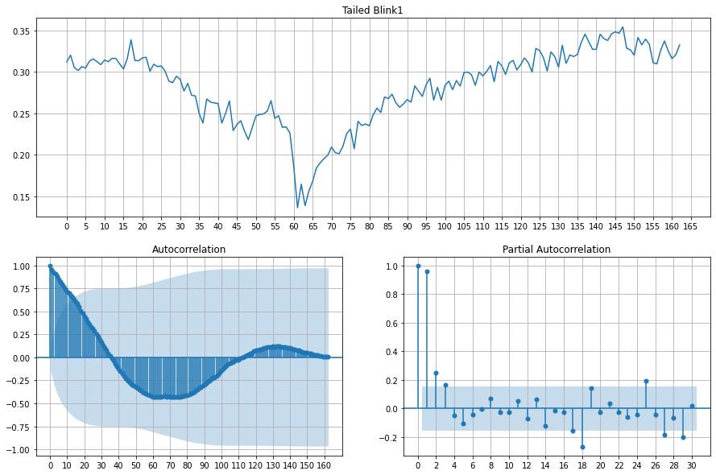

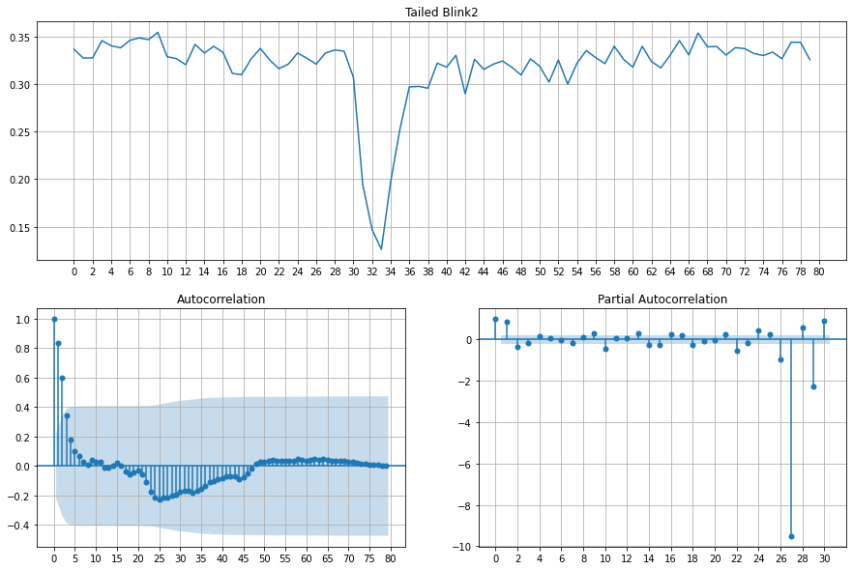

Percentiles: 25th=-0.017, 75th=0.026, IQR=0.043

Identified outliers: 13

Non-outlier observations: 205

Percentiles: 25th=0.264, 75th=0.325, IQR=0.061

Identified outliers: 7

Non-outlier observations: 211

Identified outliers: 178

Non-outlier observations: 40

Identified outliers: 197

Non-outlier observations: 21

Identified outliers: 12

Non-outlier observations: 206

Identified outliers: 12

Non-outlier observations: 206





**Experiment 2**

**Threshold = 0.3**

Video info

FPS: 30.0

FRAME_COUNT: 5000

DURATION (s): 166.67

Statistics on the prediction set are

TOTAL NUMBER OF FRAMES PROCESSED: 5000

NUMBER OF CLOSED FRAMES: 1059

NUMBER OF BLINKS: 78

Statistics on the test set are

TOTAL NUMBER OF FRAMES PROCESSED: 5000

NUMBER OF CLOSED FRAMES: 153

NUMBER OF BLINKS: 61

EYE CLOSENESS FRAME BY FRAME TEST SCORES

ACCURACY: 0.8188

AUC: 0.9065

CONFUSION MATRIX:

[[3941 906]

[ 0 153]]

FALSE POSITIVES:

0 out of 153 positive labels (0.0000%)

FALSE NEGATIVES:

906 out of 4847 negative labels (0.1869%)

PRECISION, RECALL, F1 scores:

precision recall f1-score support

0 1.00 0.81 0.90 4847

1 0.14 1.00 0.25 153

accuracy 0.82 5000

macro avg 0.57 0.91 0.57 5000

weighted avg 0.97 0.82 0.88 5000

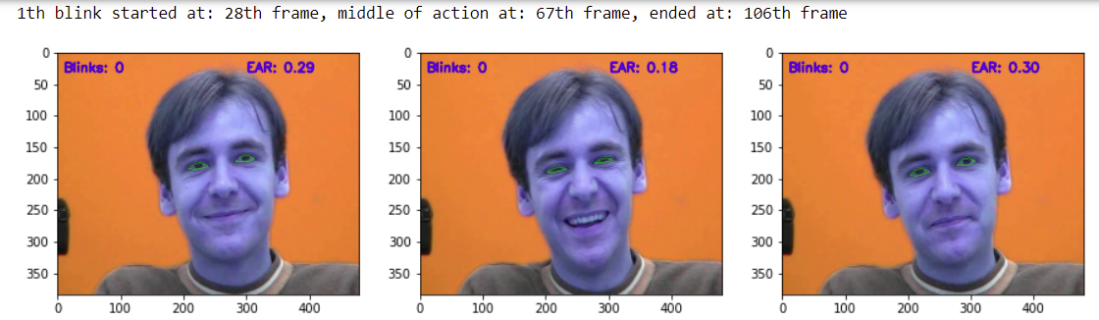

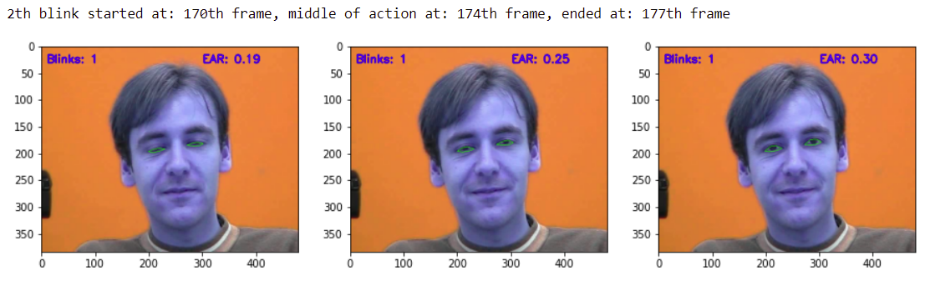

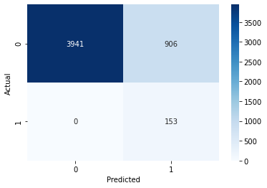

75th blink started at: 4724th frame, middle of action at: 4726th frame, ended at: 4728th frame

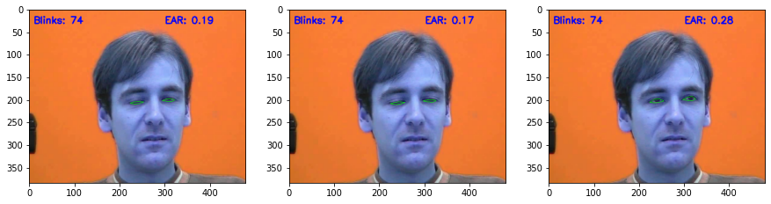

76th blink started at: 4798th frame, middle of action at: 4800th frame, ended at: 4801th frame

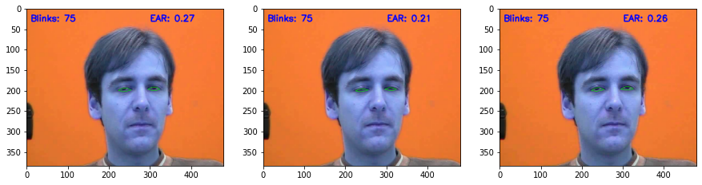

77th blink started at: 4881th frame, middle of action at: 4884th frame, ended at: 4886th frame

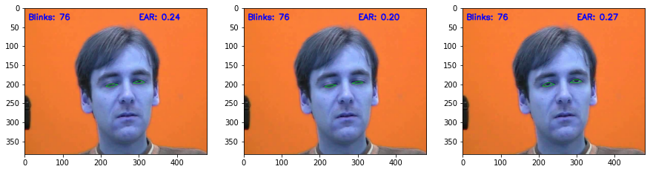

78th blink started at: 4987th frame, middle of action at: 4989th frame, ended at: 4990th frame

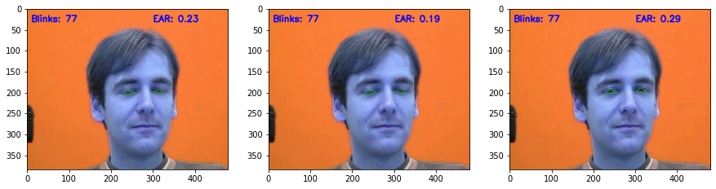

SLOPE = -0.00000







**Talking Face**

**Experiment 3 Talking dataset**

**Threshold 0.24684**

Video info

FPS: 30.0

FRAME_COUNT: 5000

DURATION (s): 166.67

Statistics on the prediction set are

TOTAL NUMBER OF FRAMES PROCESSED: 5000

NUMBER OF CLOSED FRAMES: 458

NUMBER OF BLINKS: 58

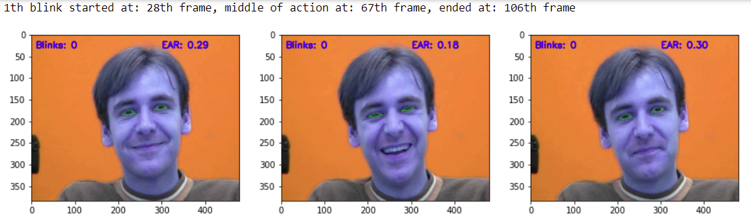

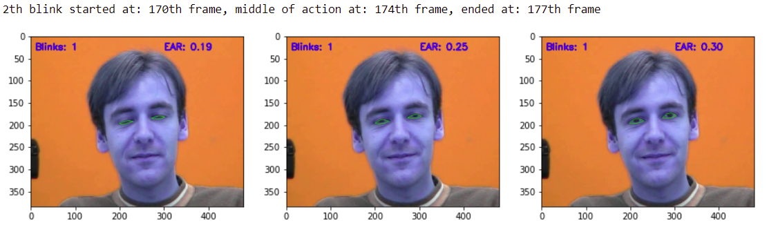

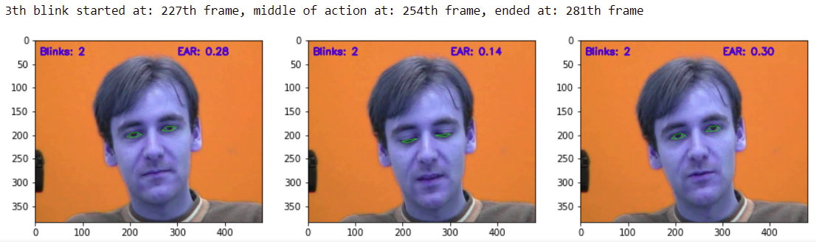

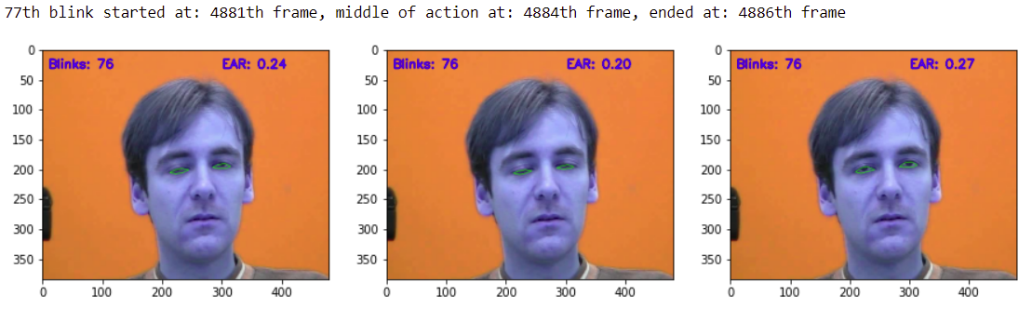

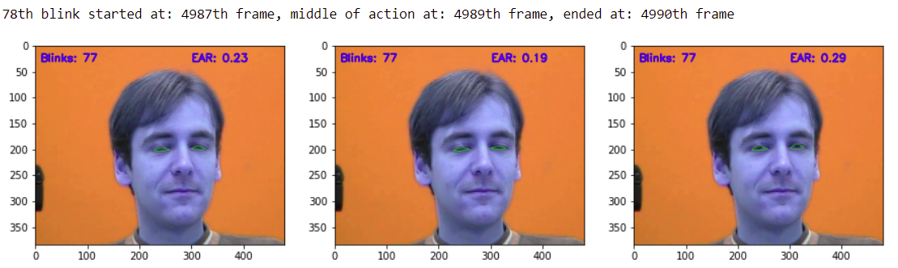

Statistics on the test set are

TOTAL NUMBER OF FRAMES PROCESSED: 5000

NUMBER OF CLOSED FRAMES: 153

NUMBER OF BLINKS: 61

EYE CLOSENESS FRAME BY FRAME TEST SCORES

ACCURACY: 0.9390

AUC: 0.9685

CONFUSION MATRIX:

[[4542 305]

[ 0 153]]

FALSE POSITIVES:

0 out of 153 positive labels (0.0000%)

FALSE NEGATIVES:

305 out of 4847 negative labels (0.0629%)

PRECISION, RECALL, F1 scores:

precision recall f1-score support

0 1.00 0.94 0.97 4847

1 0.33 1.00 0.50 153

accuracy 0.94 5000

macro avg 0.67 0.97 0.73 5000

weighted avg 0.98 0.94 0.95 5000

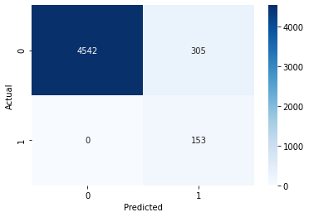







**Eyeblink 8 dataset**

E:/Eye-Blink-Detection-master/input/eyeblink8/8/27122013_151644_cam.avi

**Experiment 1**

**Threshold = 0.2**

Video info

FPS: 30.0

FRAME_COUNT: 10712

DURATION (s): 357.07

Statistics on the prediction set are

TOTAL NUMBER OF FRAMES PROCESSED: 10663

NUMBER OF CLOSED FRAMES: 529

NUMBER OF BLINKS: 43

Statistics on the test set are

TOTAL NUMBER OF FRAMES PROCESSED: 10663

NUMBER OF CLOSED FRAMES: 107

NUMBER OF BLINKS: 30

EYE CLOSENESS FRAME BY FRAME TEST SCORES

ACCURACY: 0.9597

AUC: 0.9611

CONFUSION MATRIX:

[[10130 426]

[ 4 103]]

FALSE POSITIVES:

4 out of 107 positive labels (0.0374%)

FALSE NEGATIVES:

426 out of 10556 negative labels (0.0404%)

PRECISION, RECALL, F1 scores:

precision recall f1-score support

0 1.00 0.96 0.98 10556

1 0.19 0.96 0.32 107

accuracy 0.96 10663

macro avg 0.60 0.96 0.65 10663

weighted avg 0.99 0.96 0.97 10663

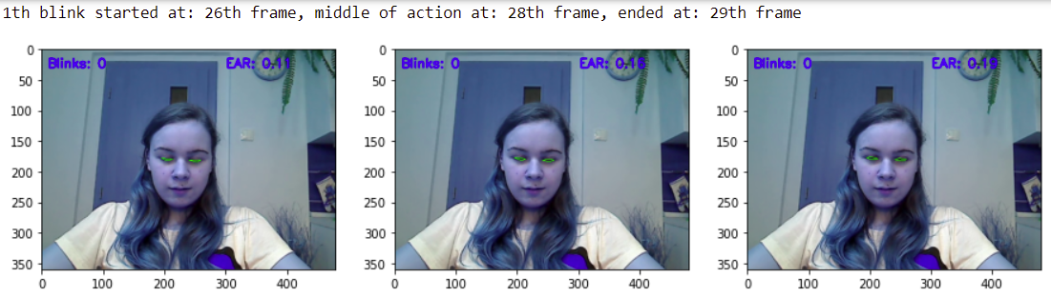

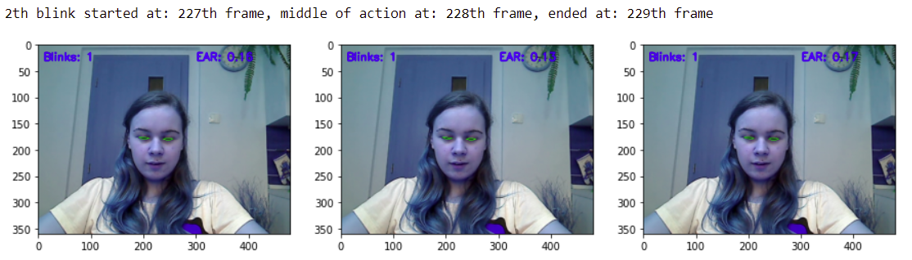

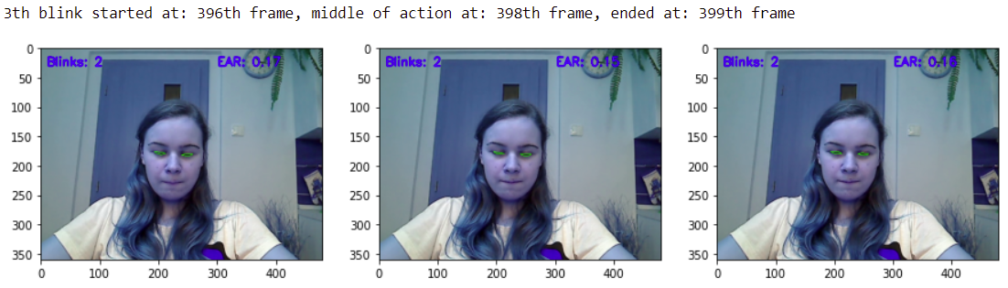

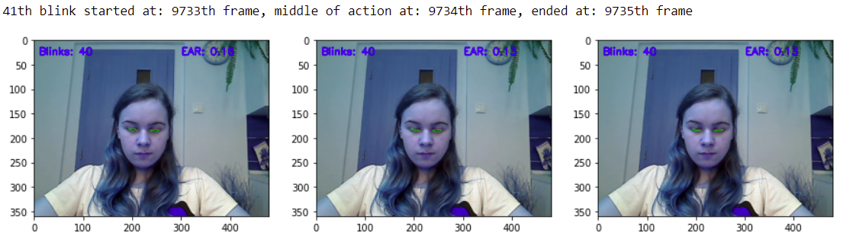

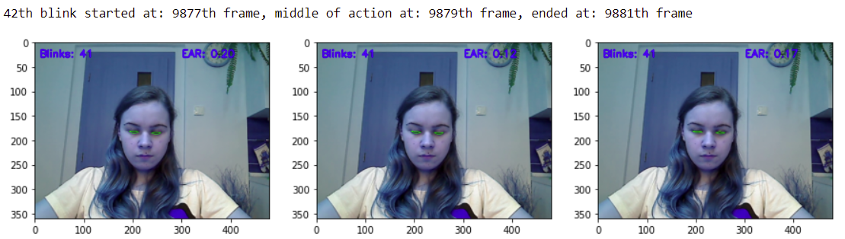

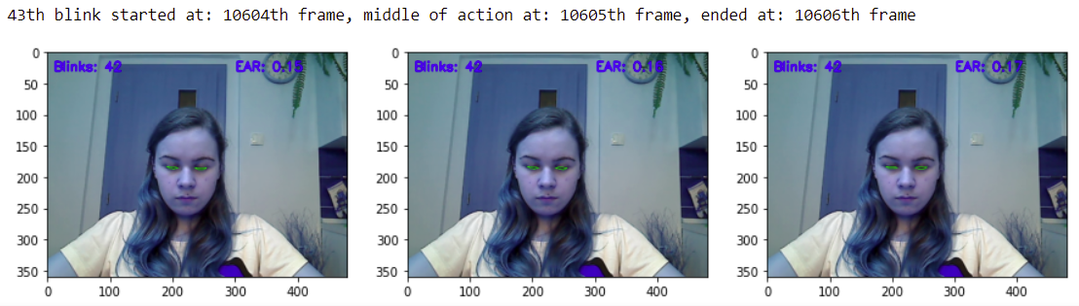

SLOPE = 0.00000

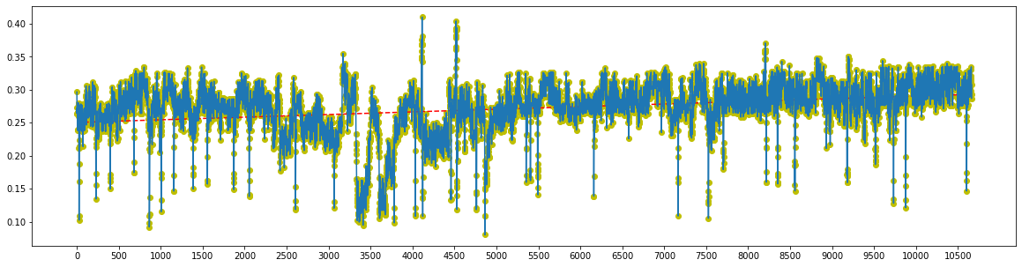

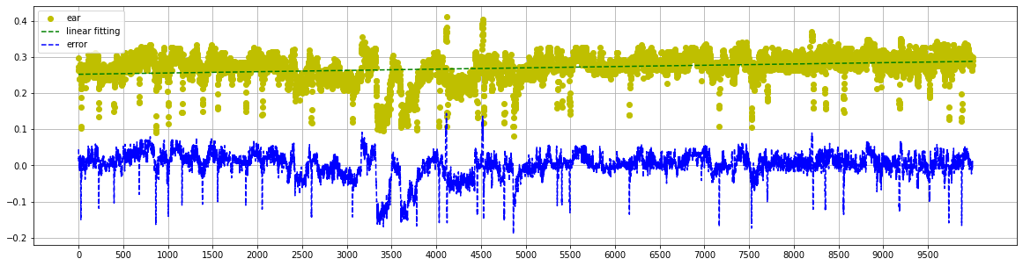

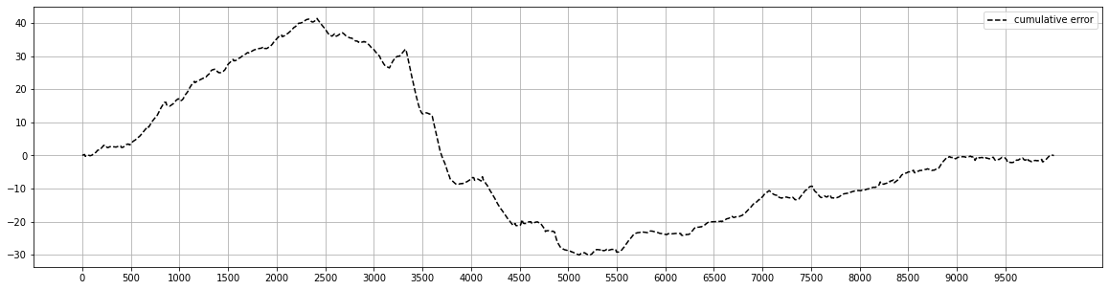

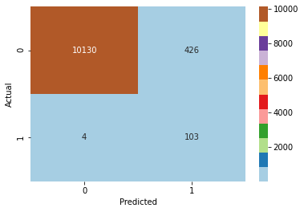

40th blink started at: 9516th frame, middle of action at: 9518th frame, ended at: 9519th frame

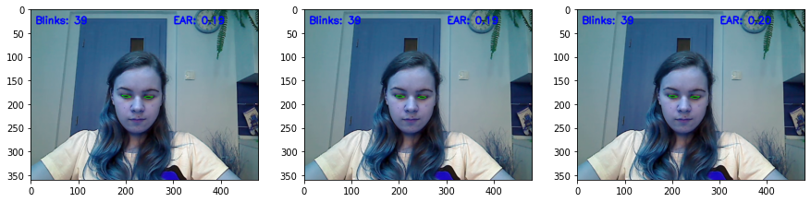

41th blink started at: 9733th frame, middle of action at: 9734th frame, ended at: 9735th frame

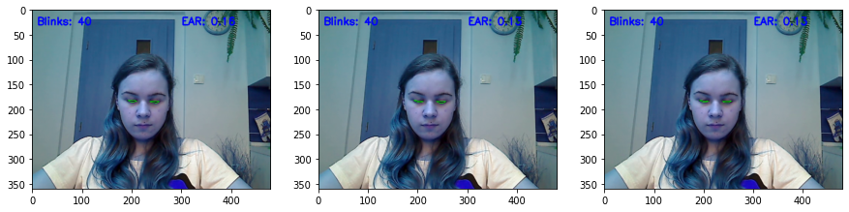

42th blink started at: 9877th frame, middle of action at: 9879th frame, ended at: 9881th frame

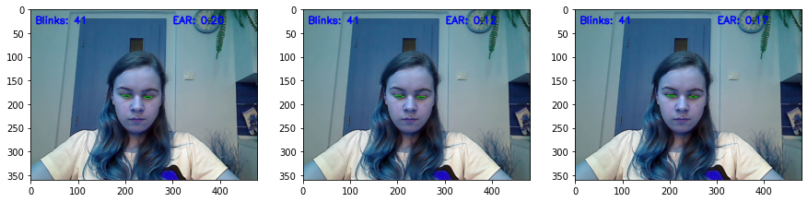

43th blink started at: 10604th frame, middle of action at: 10605th frame, ended at: 10606th frame

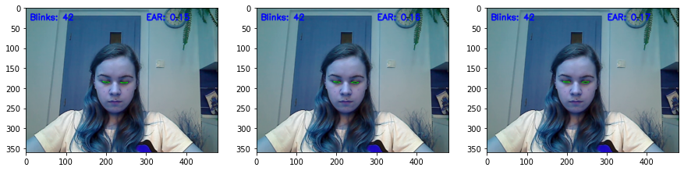

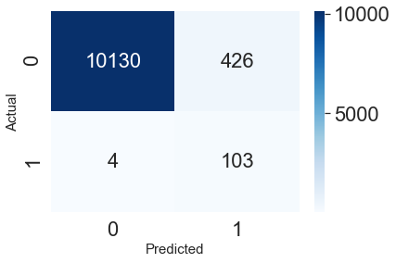

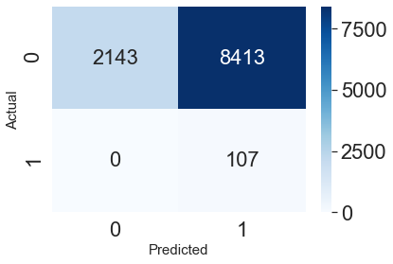

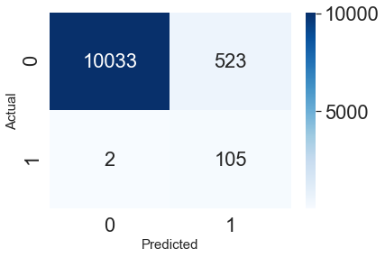

Experiment 2

"E:/Eye-Blink-Detection-master/input/eyeblink8/8/27122013_151644_cam.tag"

Threshold 0.3

Video info

FPS: 30.0

FRAME_COUNT: 10712

DURATION (s): 357.07

Statistics on the prediction set are

TOTAL NUMBER OF FRAMES PROCESSED: 10663

NUMBER OF CLOSED FRAMES: 8520

NUMBER OF BLINKS: 347

Statistics on the test set are

TOTAL NUMBER OF FRAMES PROCESSED: 10663

NUMBER OF CLOSED FRAMES: 107

NUMBER OF BLINKS: 30

EYE CLOSENESS FRAME BY FRAME TEST SCORES

ACCURACY: 0.2110

AUC: 0.6015

CONFUSION MATRIX:

[[2143 8413]

[ 0 107]]

FALSE POSITIVES:

0 out of 107 positive labels (0.0000%)

FALSE NEGATIVES:

8413 out of 10556 negative labels (0.7970%)

PRECISION, RECALL, F1 scores:

precision recall f1-score support

0 1.00 0.20 0.34 10556

1 0.01 1.00 0.02 107

accuracy 0.21 10663

macro avg 0.51 0.60 0.18 10663

weighted avg 0.99 0.21 0.33 10663

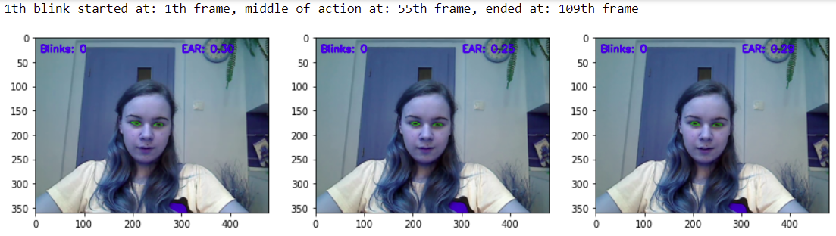

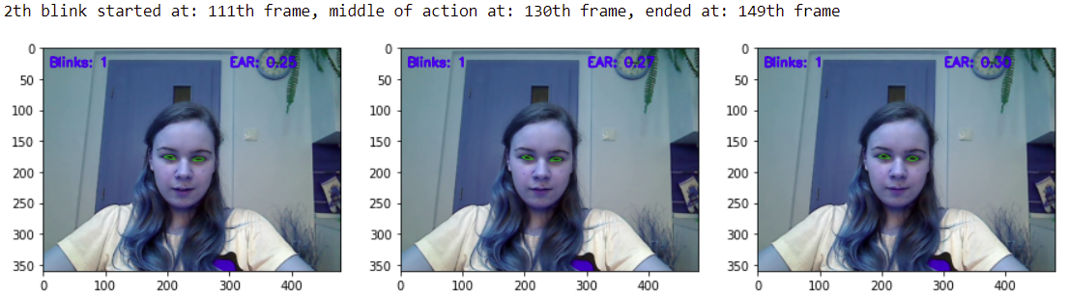

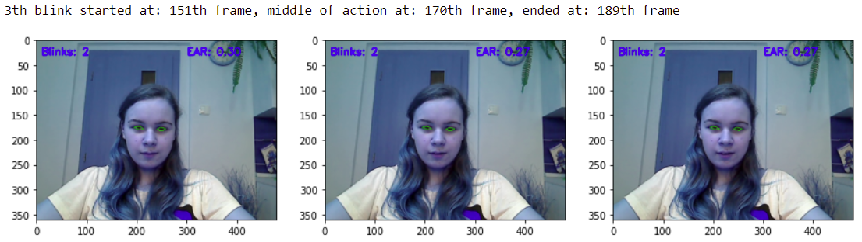

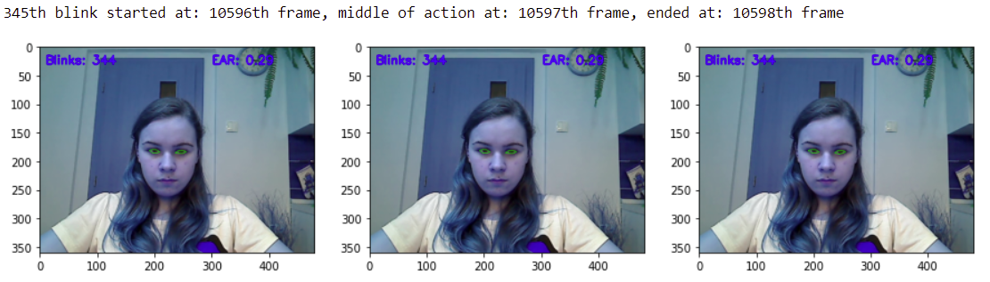

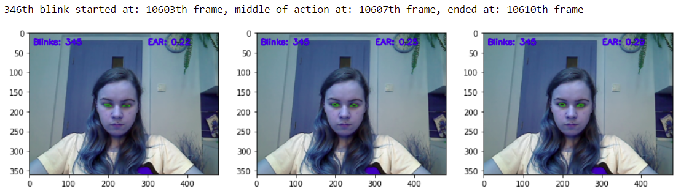

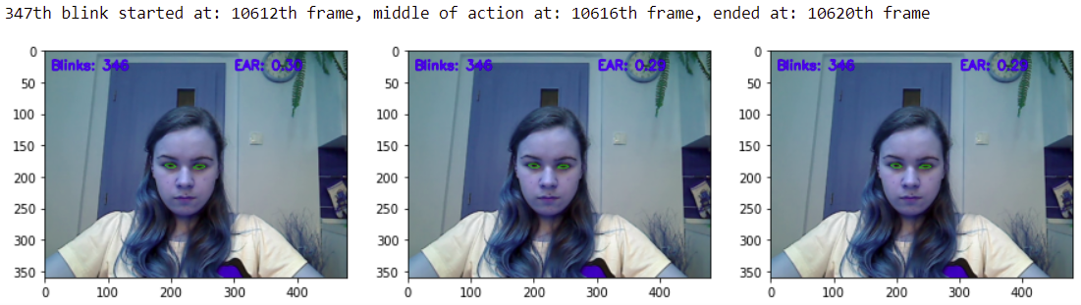

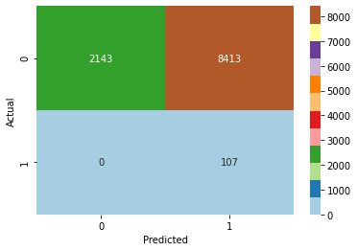

345th blink started at: 10596th frame, middle of action at: 10597th frame, ended at: 10598th frame

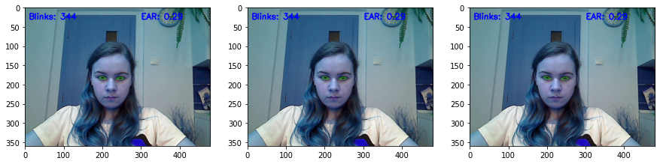

346th blink started at: 10603th frame, middle of action at: 10607th frame, ended at: 10610th frame

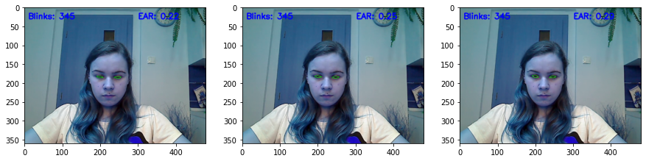

347th blink started at: 10612th frame, middle of action at: 10616th frame, ended at: 10620th frame

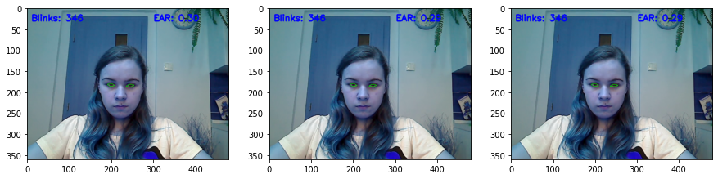

SLOPE = 0.00000







Experiment3

"E:/Eye-Blink-Detection-master/input/eyeblink8/8/27122013_151644_cam.tag"

EAR_THRESHOLD = 0.210517

Video info

FPS: 30.0

FRAME_COUNT: 10712

DURATION (s): 357.07

Statistics on the prediction set are

TOTAL NUMBER OF FRAMES PROCESSED: 10663

NUMBER OF CLOSED FRAMES: 628

NUMBER OF BLINKS: 51

Statistics on the test set are

TOTAL NUMBER OF FRAMES PROCESSED: 10663

NUMBER OF CLOSED FRAMES: 107

NUMBER OF BLINKS: 30

EYE CLOSENESS FRAME BY FRAME TEST SCORES

ACCURACY: 0.9508

AUC: 0.9659

CONFUSION MATRIX:

[[10033 523]

[ 2 105]]

FALSE POSITIVES:

2 out of 107 positive labels (0.0187%)

FALSE NEGATIVES:

523 out of 10556 negative labels (0.0495%)

PRECISION, RECALL, F1 scores:

precision recall f1-score support

0 1.00 0.95 0.97 10556

1 0.17 0.98 0.29 107

accuracy 0.95 10663

macro avg 0.58 0.97 0.63 10663

weighted avg 0.99 0.95 0.97 10663

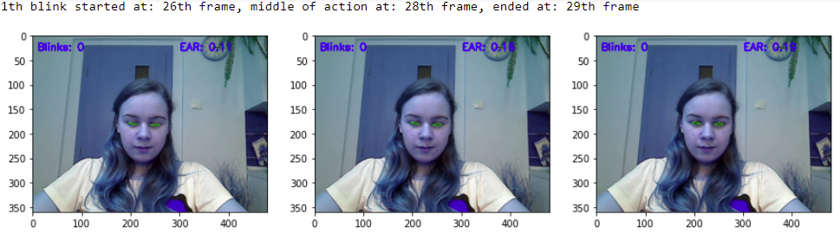

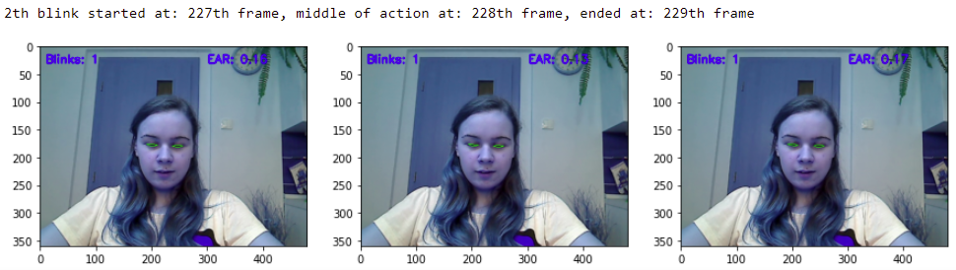

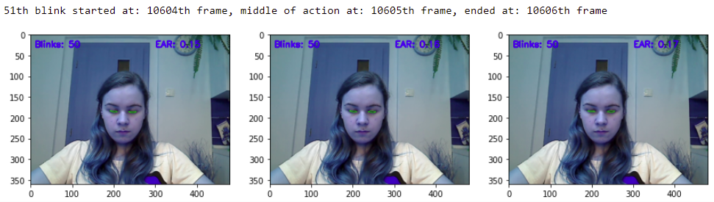

SLOPE = 0.00000







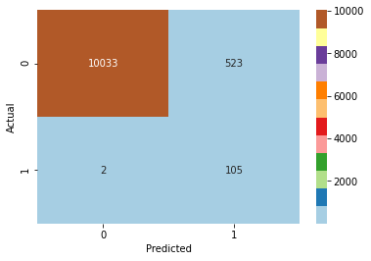

45th blink started at: 8351th frame, middle of action at: 8354th frame, ended at: 8356th frame

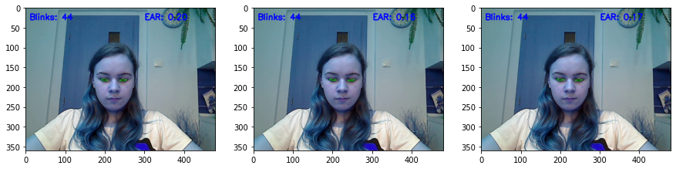

46th blink started at: 8556th frame, middle of action at: 8558th frame, ended at: 8560th frame

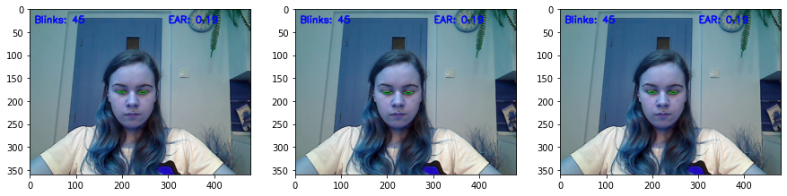

47th blink started at: 9178th frame, middle of action at: 9182th frame, ended at: 9186th frame

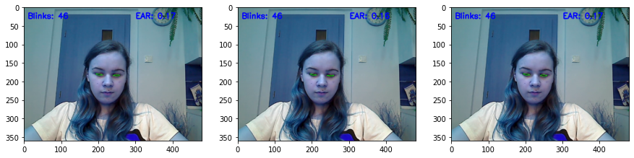

48th blink started at: 9516th frame, middle of action at: 9518th frame, ended at: 9520th frame

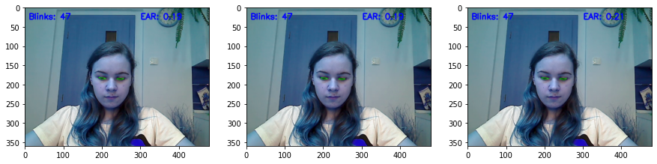

49th blink started at: 9733th frame, middle of action at: 9734th frame, ended at: 9735th frame

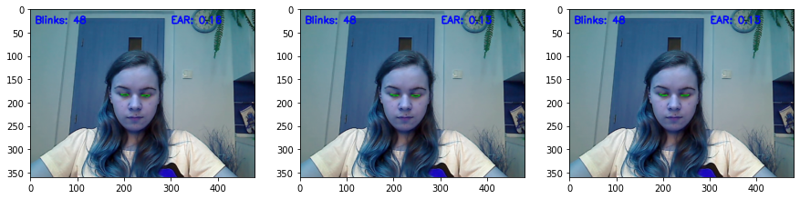

50th blink started at: 9877th frame, middle of action at: 9879th frame, ended at: 9881th frame

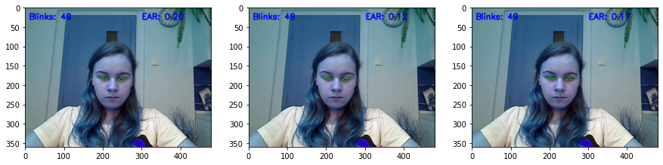

51th blink started at: 10604th frame, middle of action at: 10605th frame, ended at: 10606th frame

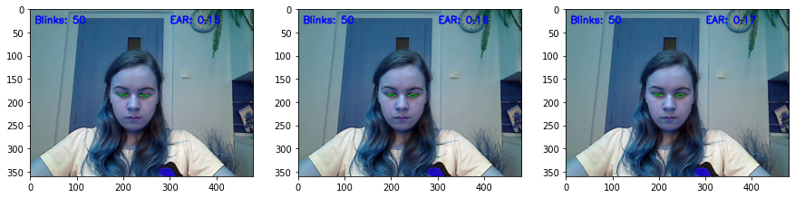

Experiment 4

EAR_THRESHOLD = 0.249905

file_path = "E:/Eye-Blink-Detection-master/input/eyeblink8/8/27122013_151644_cam.avi"

Video info

FPS: 30.0

FRAME_COUNT: 10712

DURATION (s): 357.07

Statistics on the prediction set are

TOTAL NUMBER OF FRAMES PROCESSED: 10663

NUMBER OF CLOSED FRAMES: 1991

NUMBER OF BLINKS: 124

Statistics on the test set are

TOTAL NUMBER OF FRAMES PROCESSED: 10663

NUMBER OF CLOSED FRAMES: 107

NUMBER OF BLINKS: 30

EYE CLOSENESS FRAME BY FRAME TEST SCORES

ACCURACY: 0.8233

AUC: 0.9108

CONFUSION MATRIX:

[[8672 1884]

[ 0 107]]

FALSE POSITIVES:

0 out of 107 positive labels (0.0000%)

FALSE NEGATIVES:

1884 out of 10556 negative labels (0.1785%)

PRECISION, RECALL, F1 scores:

precision recall f1-score support

0 1.00 0.82 0.90 10556

1 0.05 1.00 0.10 107

accuracy 0.82 10663

macro avg 0.53 0.91 0.50 10663

weighted avg 0.99 0.82 0.89 10663

1th blink started at: 25th frame, middle of action at: 28th frame, ended at: 31th frame

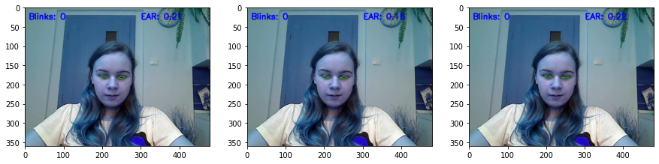

2th blink started at: 62th frame, middle of action at: 63th frame, ended at: 64th frame

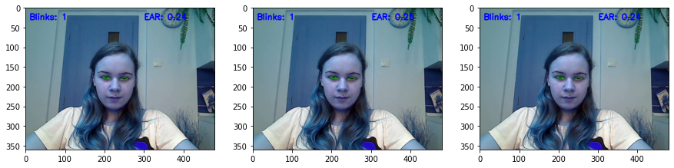

3th blink started at: 73th frame, middle of action at: 75th frame, ended at: 76th frame

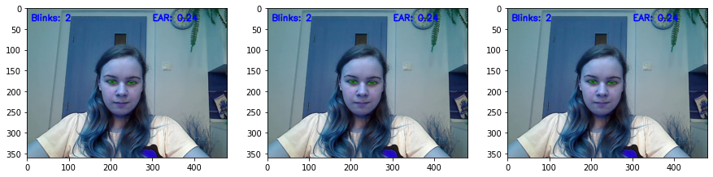

121th blink started at: 9687th frame, middle of action at: 9689th frame, ended at: 9690th frame

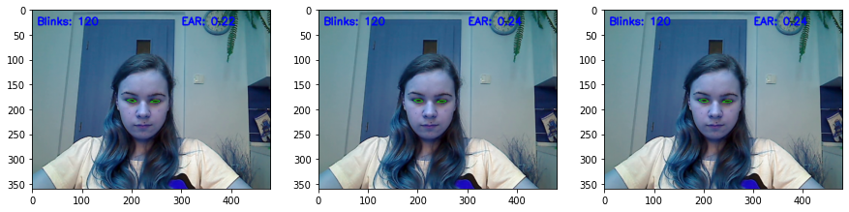

122th blink started at: 9732th frame, middle of action at: 9734th frame, ended at: 9736th frame

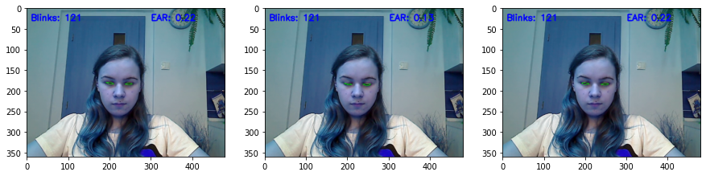

123th blink started at: 9877th frame, middle of action at: 9879th frame, ended at: 9881th frame

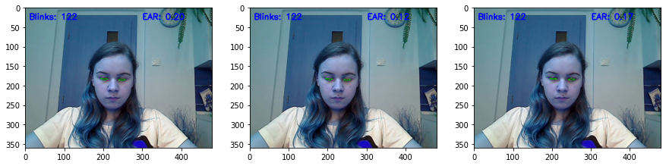

124th blink started at: 10603th frame, middle of action at: 10605th frame, ended at: 10606th frame

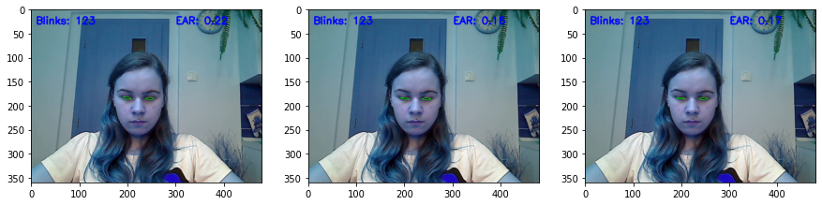

SLOPE = 0.00000







file_path = "E:/Eye-Blink-Detection-master/input/eyeblink8/4/26122013_230654_cam.avi"

Experiment 1

Threshold 0.2

Video info

FPS: 30.0

FRAME_COUNT: 5454

DURATION (s): 181.80

Statistics on the prediction set are

TOTAL NUMBER OF FRAMES PROCESSED: 5315

NUMBER OF CLOSED FRAMES: 123

NUMBER OF BLINKS: 15

Statistics on the test set are

TOTAL NUMBER OF FRAMES PROCESSED: 5315

NUMBER OF CLOSED FRAMES: 117

NUMBER OF BLINKS: 31

EYE CLOSENESS FRAME BY FRAME TEST SCORES

ACCURACY: 0.9819

AUC: 0.8028

CONFUSION MATRIX:

[[5147 51]

[ 45 72]]

FALSE POSITIVES:

45 out of 117 positive labels (0.3846%)

FALSE NEGATIVES:

51 out of 5198 negative labels (0.0098%)

PRECISION, RECALL, F1 scores:

precision recall f1-score support

0 0.99 0.99 0.99 5198

1 0.59 0.62 0.60 117

accuracy 0.98 5315

macro avg 0.79 0.80 0.80 5315

weighted avg 0.98 0.98 0.98 5315

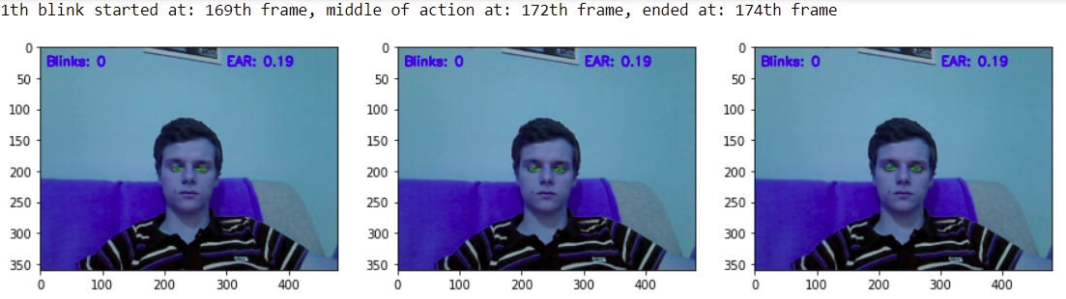

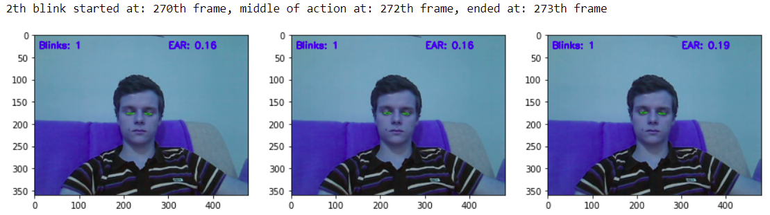

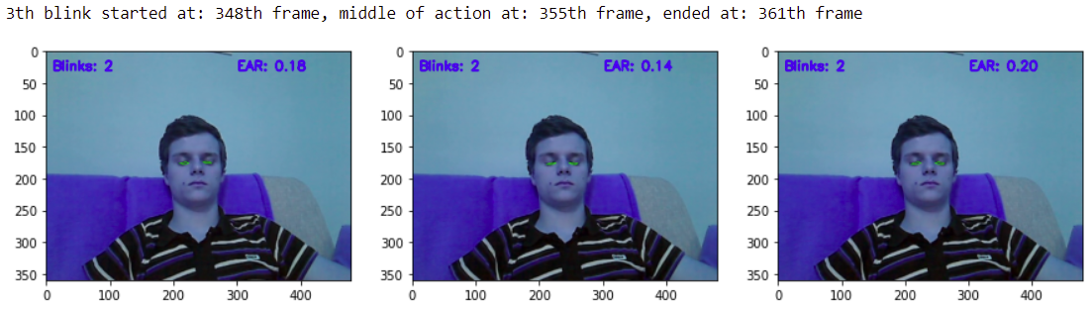

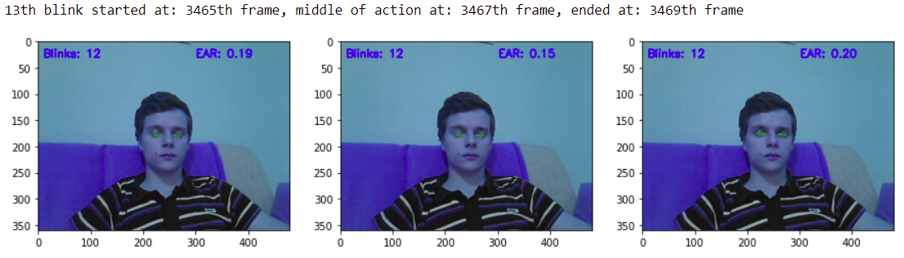

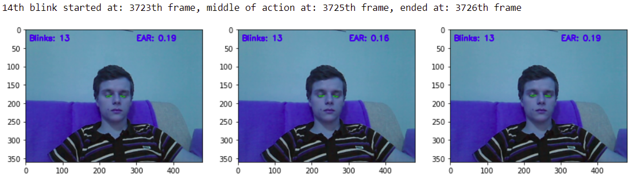

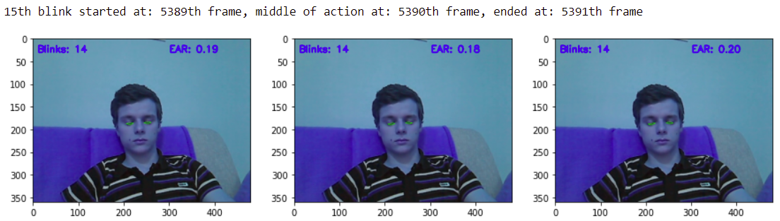

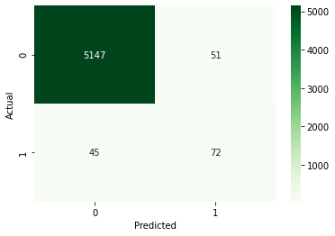

SLOPE = 0.00001

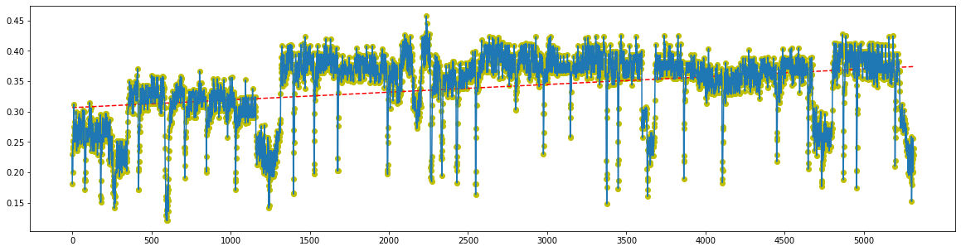

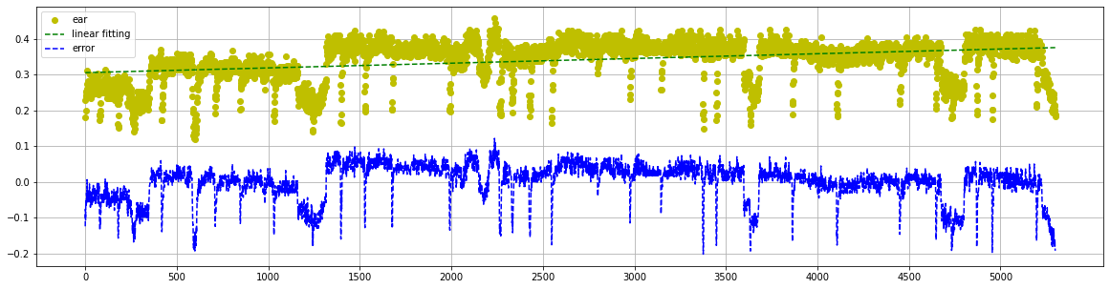

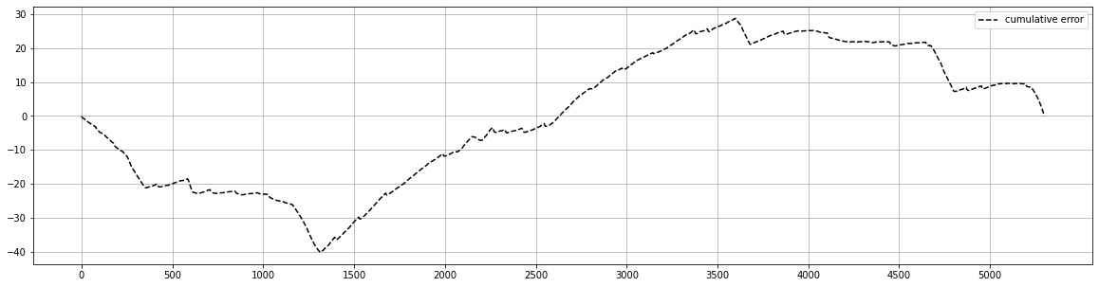

1th blink started at: 169th frame, middle of action at: 172th frame, ended at: 174th frame

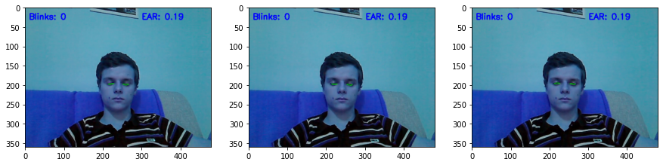

2th blink started at: 270th frame, middle of action at: 272th frame, ended at: 273th frame

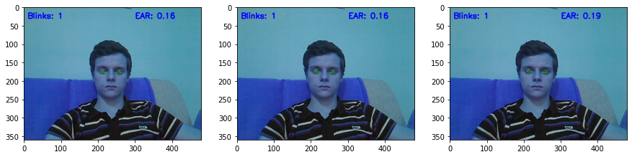

3th blink started at: 348th frame, middle of action at: 355th frame, ended at: 361th frame

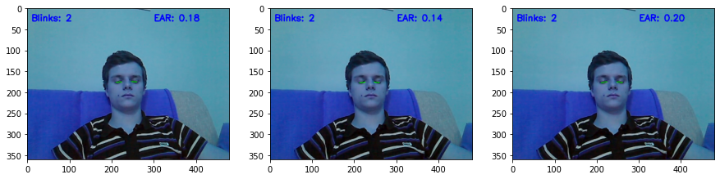

4th blink started at: 363th frame, middle of action at: 365th frame, ended at: 366th frame

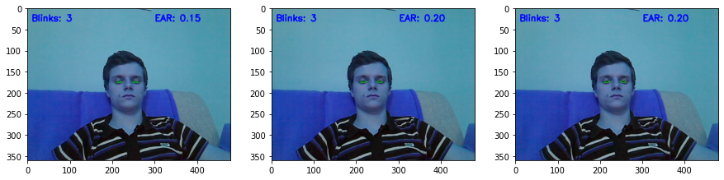

5th blink started at: 679th frame, middle of action at: 689th frame, ended at: 699th frame

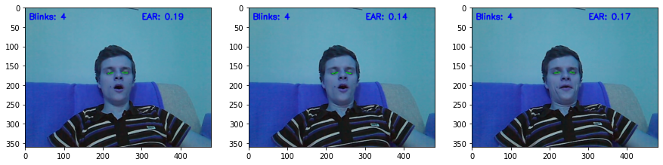

13th blink started at: 3465th frame, middle of action at: 3467th frame, ended at: 3469th frame

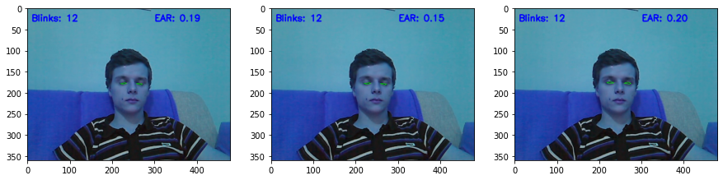

file_path = "E:/Eye-Blink-Detection-master/input/eyeblink8/4/26122013_230654_cam.avi"

Experiment 2

Threshold 0.3

Video info

FPS: 30.0

FRAME_COUNT: 5454

DURATION (s): 181.80

Statistics on the prediction set are

TOTAL NUMBER OF FRAMES PROCESSED: 5315

NUMBER OF CLOSED FRAMES: 1081

NUMBER OF BLINKS: 54

Statistics on the test set are

TOTAL NUMBER OF FRAMES PROCESSED: 5315

NUMBER OF CLOSED FRAMES: 117

NUMBER OF BLINKS: 31

EYE CLOSENESS FRAME BY FRAME TEST SCORES

ACCURACY: 0.8186

AUC: 0.9073

CONFUSION MATRIX:

[[4234 964]

[ 0 117]]

FALSE POSITIVES:

0 out of 117 positive labels (0.0000%)

FALSE NEGATIVES:

964 out of 5198 negative labels (0.1855%)

PRECISION, RECALL, F1 scores:

precision recall f1-score support

0 1.00 0.81 0.90 5198

1 0.11 1.00 0.20 117

accuracy 0.82 5315

macro avg 0.55 0.91 0.55 5315

weighted avg 0.98 0.82 0.88 5315

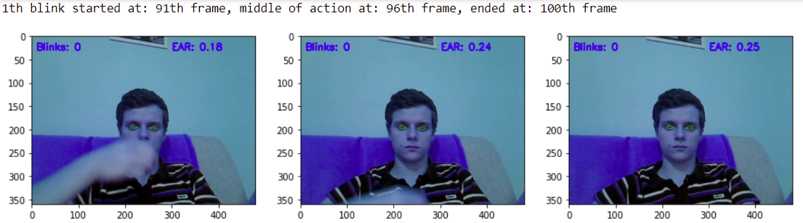

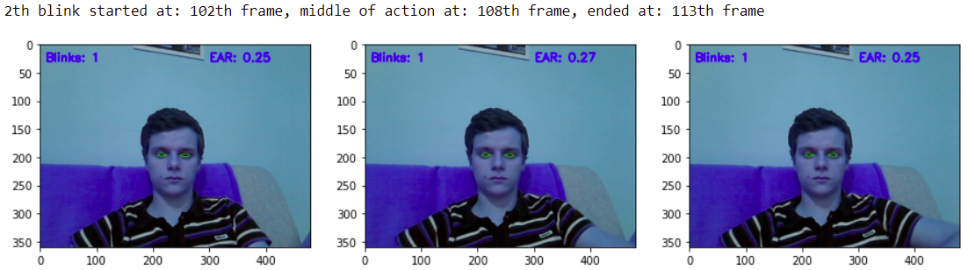

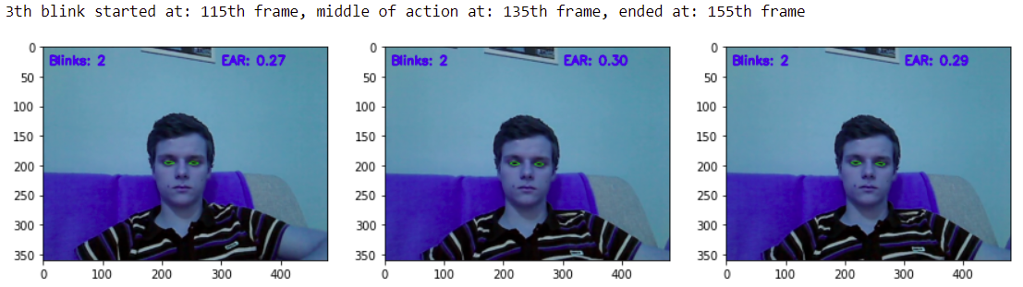

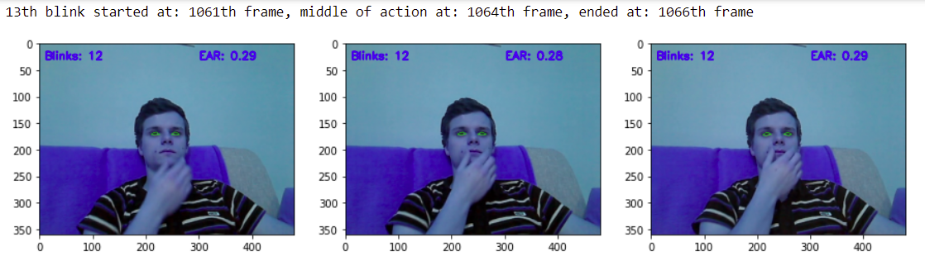

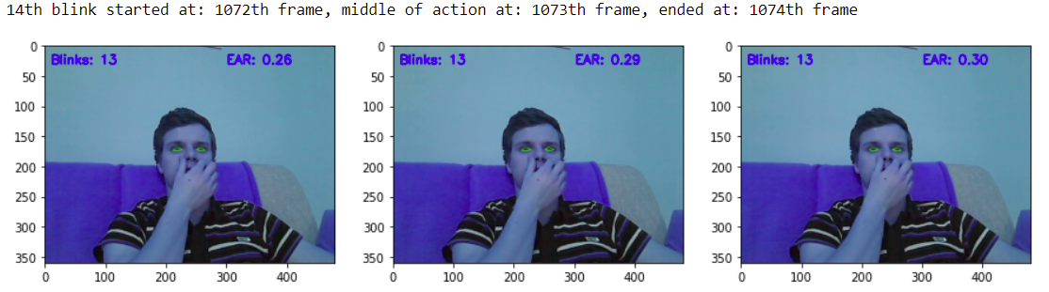

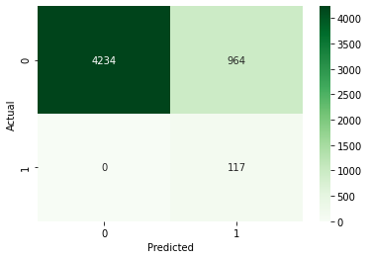

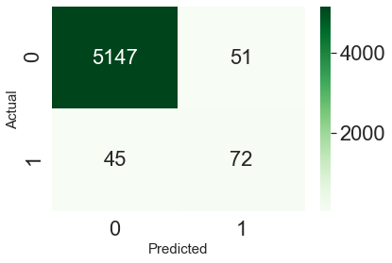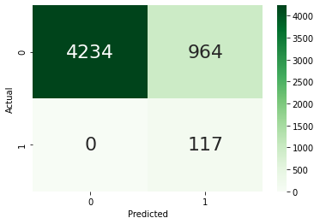

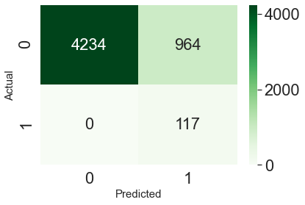

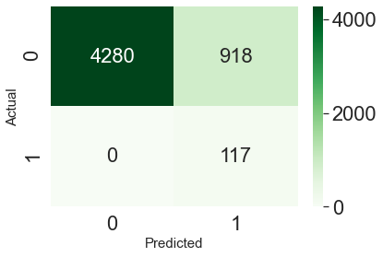

SLOPE = 0.00001



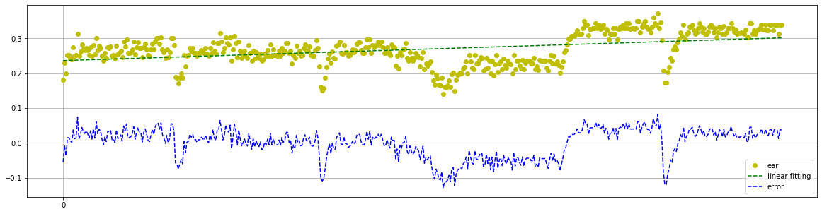

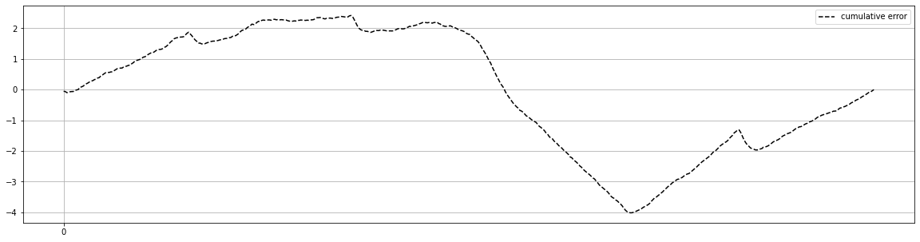

Experiment 3

EAR_THRESHOLD = 0.292357

file_path = "E:/Eye-Blink-Detection-master/input/eyeblink8/4/26122013_230654_cam.avi"

Video info

FPS: 30.0

FRAME_COUNT: 5454

DURATION (s): 181.80

Statistics on the prediction set are

TOTAL NUMBER OF FRAMES PROCESSED: 5315

NUMBER OF CLOSED FRAMES: 1035

NUMBER OF BLINKS: 54

Statistics on the test set are

TOTAL NUMBER OF FRAMES PROCESSED: 5315

NUMBER OF CLOSED FRAMES: 117

NUMBER OF BLINKS: 31

EYE CLOSENESS FRAME BY FRAME TEST SCORES

ACCURACY: 0.8273

AUC: 0.9117

CONFUSION MATRIX:

[[4280 918]

[ 0 117]]

FALSE POSITIVES:

0 out of 117 positive labels (0.0000%)

FALSE NEGATIVES:

918 out of 5198 negative labels (0.1766%)

PRECISION, RECALL, F1 scores:

precision recall f1-score support

0 1.00 0.82 0.90 5198

1 0.11 1.00 0.20 117

accuracy 0.83 5315

macro avg 0.56 0.91 0.55 5315

weighted avg 0.98 0.83 0.89 5315

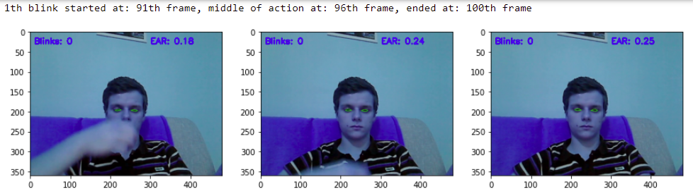

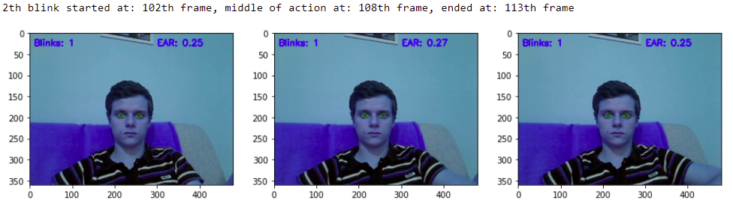

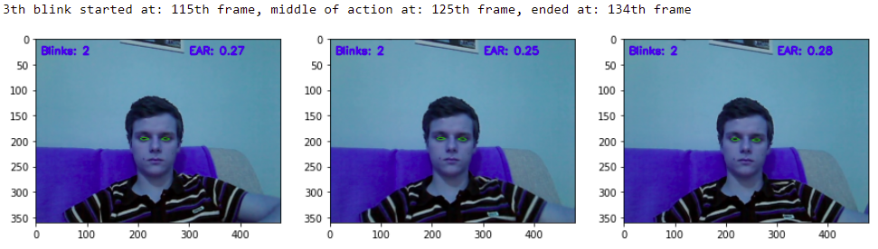

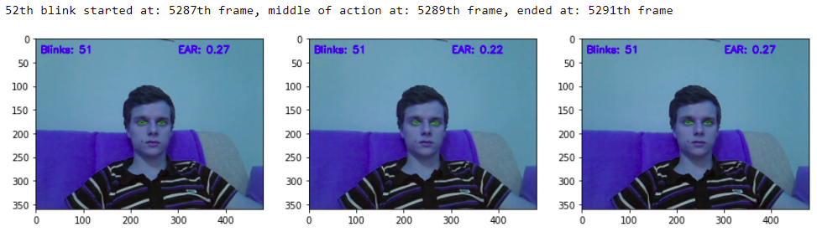

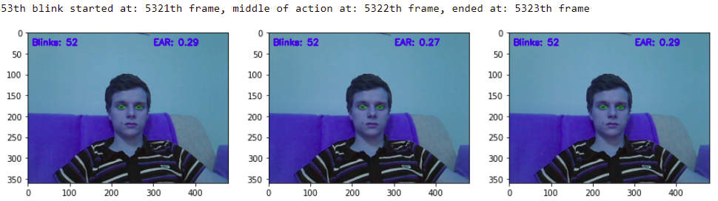

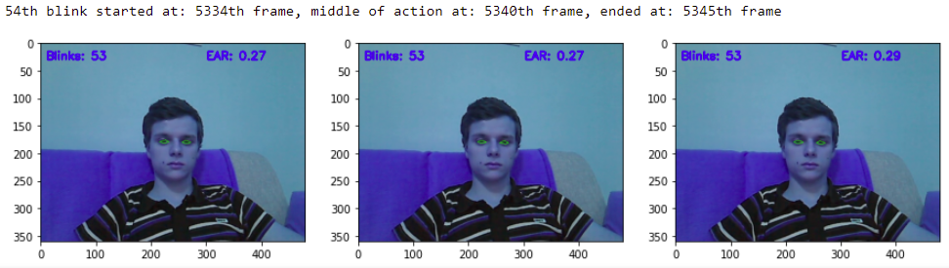

SLOPE = 0.00001







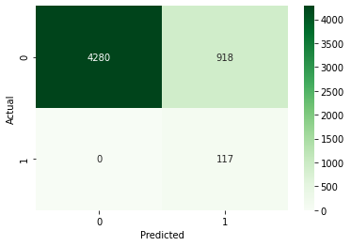

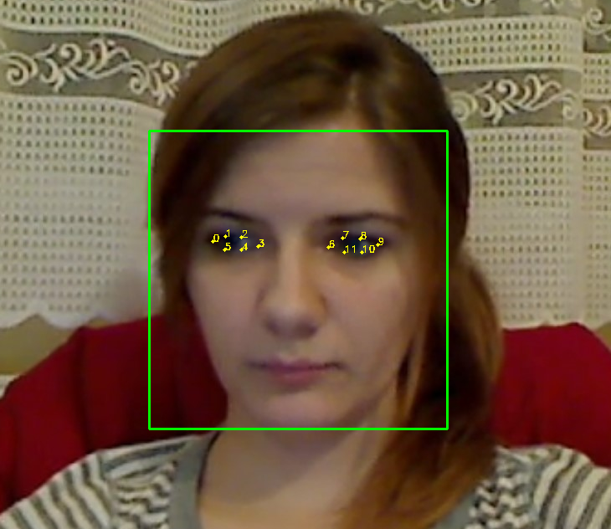

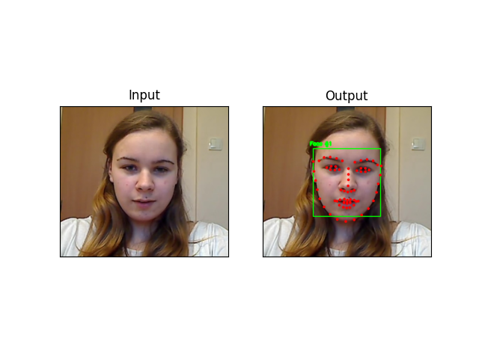

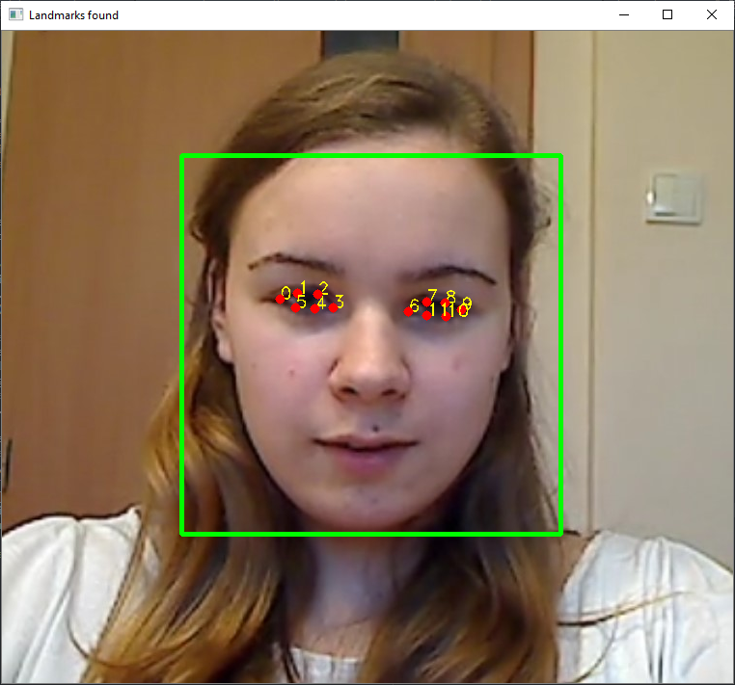

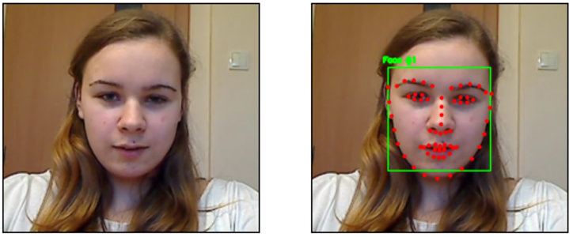

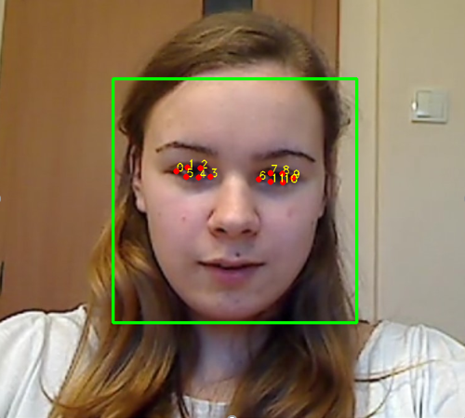

Eye Detection



Facial Landmarks Detection

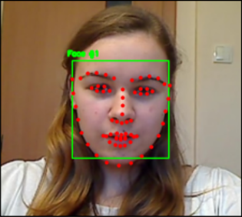

Input Video

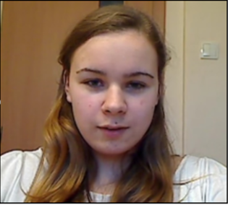





(a) First Blink



(b) Second Blink



(c) EAR, Linear Fitting and Error Analysis